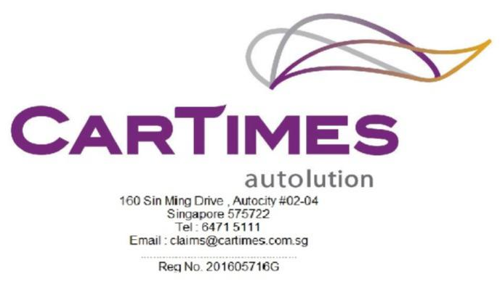

_____________________________________________________________________________________
Our Ref: SKN 1213 S

Your Ref: PC 7363 B

29 NOVEMBER 2022

MS First Capital Insurance Ltd BY EMAIL ONLY
36 Robinson Road (motor_claims@first-insurance.com.sg)
#16-01
City House
Singapore 068877
Dear Sir,
RE: PROPERTY DAMAGE CLAIM
CLAIMANT : JURONG ENGINEERING LIMITED
ACCIDENT INVOLVING SKN 1213 S & PC 7363 B ALONG BUKIT MANIS ROAD ON 25/11/2022.

- We act for JURONG ENGINEERING LIMITED, the owner of motor vehicle no. SKN 1213 S, which was involved in the aforesaid accident.

- We hereby give you NOTICE that we are claiming against your insured motor vehicle no. PC 7363 B for damages, costs and disbursements as a result of your insured driver’s negligence.

- Kindly let us know if you wish to conduct a pre-repair inspection on our client’s motor vehicle at M/s Cartimes Autolution at 160 Sin Ming Drive #02-04 Autocity Singapore 575722 and kindly arrange with Huey Qi at 6471 5111.

- If we do not here from you within the next two (2) working days , we shall advice our client to proceed with their own inspection and repairs.
Yours Sincerely
Huey Qi

