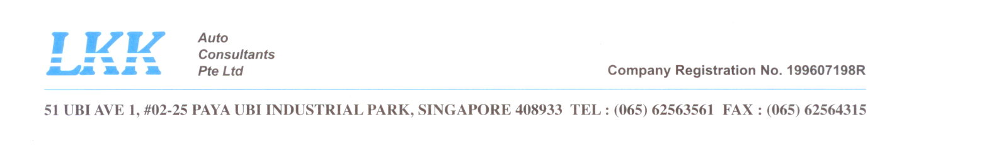

Asset Value-Residual Value
Asset life

To calculate the value of a fixed asset (TMA) costing $38,000.00 (INV 00210168) at the time of the accident using the “Straight Line Depreciation Method”.

Fixed Asset Cost $38,000.00
Estimate Residual Value $200.00
Estimated useful life 20 years

Depreciation Charge p.a = Fixed Asset cost $38,000.00 – Residual Value $200.00
Estimated useful life 20 years
= $1,890.00 per year
i.e $157.50 per month

Beginning 1st year $38,000.00
Usage rate after 10 years 5mths (125months of $157.50 x125=$19,687.50) -$19,687.50
Balance Value $18,312.50
=========

