Your Ref: CC2/MIDA22006981/p
Our Ref: MT/CA/TP/010/1177519-002/EHH 19 May 2023

LKK AUTO CONSULTANTS PTE LTD 51 UBI AVENUE 1
#02-25 PAYA UBI INDUSTRIAL PARK SINGAPORE 408933

WITHOUT PREJUDICE SAVE AS TO COSTS


Dear Sir/Madam

CLAIM NUMBER: MT/1177519-002
ACCIDENT INVOLVING SKU6340M / MID46196 on 22 Jun 2022

We refer to your claim.

We are pleased to offer S$841.17 in settlement of your claim. Please note the amount offered is non-transferrable and non-assignable to any third parties outside the settlement agreement.

If our offer is acceptable, please sign and return the discharge voucher so that we can arrange payment to you.

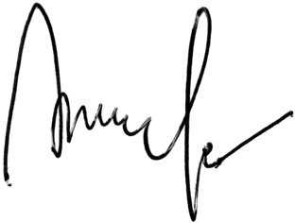
If you have any queries, please contact Eng Huey Huey at 6430 7921 or email us at motor@income.com.sg. Yours sincerely

Jenny Pe
Deputy Vice President Motor Insurance

NB: $841.17 [COR $926.35 (w/GST)x90%, LTA $7.45]

Your Ref: CC2/MIDA22006981/p
Our Ref: MT/CA/TP/010/1177519-002/EHH 19 May 2023

DISCHARGE VOUCHER I/We, PS DEFENCE
hereby acknowledge and agree that payment by Income Insurance Limited of the sum
of S$841.17 to PS DEFENCE shall be full satisfaction liquidation and discharge of all claims whatsoever competent upon OSCARS LEASING PRIVATE LIMITED &/OR AUTHORISED DRIVER in respect of all loss injury or damage whether now or hereafter to become manifest arising directly or indirectly from the
above-captioned accident.

I/We acknowledge that this payment is made without any admission of liability on part of Income Insurance Limited.

I/We understand and agree that the entitlement to receive the payment is non-transferrable and/or non-assignable to any third parties not named in this agreement.

Signature : Name :
(Include company stamp if applicable) NRIC/UEN :
Date :

Witness
Signature : Name :
NRIC No :

Address :

NB: $841.17 [COR $926.35 (w/GST)x90%, LTA $7.45]

