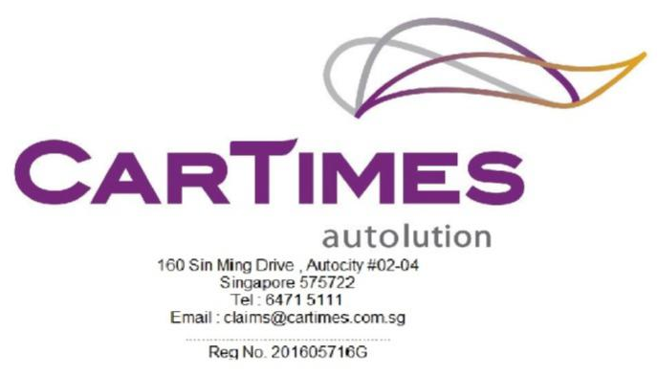

_____________________________________________________________________________________
Our Ref: SMV 5672 H

Your Ref: SMQ 8539 S

08 APRIL 2022

China Taiping Insurance (Singapore) Pte Ltd BY EMAIL ONLY
3 Anson Road (claimsdept@sg.cntaiping.com)
#16-00 Springleaf Tower
Singapore 079909

Dear Sir,
RE: PROPERTY DAMAGE CLAIM
CLAIMANT : CAR TIMES AUTO-RENT PTE LTD
ACCIDENT INVOLVING SMV 5672 H & SMQ 8539 S AT TELOK BLANGAH RD ON 02/04/2022.

- We act for CAR TIMES AUTO-RENT PTE LTD, the owner of motor vehicle no. SMV 5672 H, which was involved in the aforesaid accident.

- We hereby give you NOTICE that we are claiming against your insured motor vehicle no. SMQ 8539 S for damages, costs and disbursements as a result of your insured driver’s negligence.

- Kindly let us know if you wish to conduct a pre-repair inspection on our client’s motor vehicle at M/s Cartimes Autolution at 160 Sin Ming Drive #02-04 Autocity Singapore 575722 and kindly arrange with Ms Huey Qi at 6471 5111.

- If we do not here from you within the next two (2) working days , we shall advice our client to proceed with their own inspection and repairs.
Yours Sincerely
Ms Huey Qi
TEL 6471 5111

