From: SL LAW PRS <prs@sllaw.com.sg>
Sent: Friday, 14 January 2022 3:17 pm
To: Joanne Tan Jo Ann <joannetan@msfirstcapital.com.sg>
Cc: xinyunauto1@gmail.com; aarontkj.sk@gmail.com; Esther Lim <EstherLim@msfirstcapital.com.sg>; Harminder Kaur <Harminder@msfirstcapital.com.sg>
Subject: RE: D22000165MFCV/GBL/EL - URGENT ACCIDENT INVOLVING SKG3527K & GBE7691J ALONG MONTREAL LINK ALONG SEMBAWANG ON 13 JANUARY 2022 AT ABOUT 1820 HOURS || PD.192317
Importance: High

WITHOUT PREJUDICE

Dear Sir/Madam,

ACCIDENT INVOLVING SKG3527K & GBE7691J ALONG MONTREAL LINK ALONG SEMBAWANG ON 13 JANUARY 2022 AT ABOUT 1820 HOURS

We refer to the matter above and your email of even date and thank you for confirming your intention to conduct a pre-repair survey on our client's vehicle SKG3527K.

We have our client’s instructions to appoint your surveyors LKK Auto Consultants Pte Ltd for the SJE.

Please be informed that said vehicle can be inspected at:

Workshop: Xin Yun Auto Private Limited
Address: Blk 8 Kaki Bukit Ave 4 #05-23 Premier @ Kaki Bukit Singapore 415675
Contact Person: Yi Xin (HP: 9839 1555)

*Please be in touch with the contact person for further arrangement urgently.

In the event you fail to conduct the pre-repair survey within the next 2 working days, excluding any intervening Saturday, Sunday or Public Holiday, the said workshop will commence repairs thereafter without further reference to you.

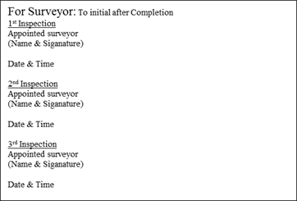

Thank you.

*Please direct all future correspondence to our new address:
133 New Bridge Road
#13-01 Chinatown Point
Singapore 059413

Regards
Wati Fhatullah
DID: 6909 9355 Fax: 6909 6246
Address: 133 New Bridge Road #13-01 Chinatown Point Singapore 059413



This e-mail is intended solely for the person to whom it has been addressed. It may contain confidential and/or legally privileged information. If you are not the person for whom this e-mail was intended, or if this e-mail has reached you by mistake, please delete it immediately and inform us of the error. Internet communications may not be entirely secure or accurate as information could be intercepted, corrupted, lost, arrive late or contain viruses. Therefore, we do not accept liability for any errors or omissions in the content of this message which may arise as a result of Internet transmission.

