OUR REF : ALL.Y1.2100256-ig
YOUR REF : SHD 3104Z

29 September 2021

AXA INSURANCE SINGAPORE PTE LTD
8 Shenton Way
#27-01
Singapore 068811

Dear Sir

1. NOTICE OF ACCIDENT TO INSURERS AND PRE-REPAIR SURVEY WITHIN 2 WORKING DAYS PURSUANT TO PARAGRAPH 2 OF THE STATE COURTS PRACTICE DIRECTIONS (AMENDMENT NO. 1 OF 2016)

2. ROAD TRAFFIC ACCIDENT ON 28/09/2021 INVOLVING VEHICLE NOS. SMG 4444K & SHD 3104Z ALONG CHOA CHU KANG NORTH 7 AT ABOUT 1245 HOURS

We are instructed by MISS VERNIE WONG WAN SZE (owner of motor vehicle no. SMG 4444K) and/or ysk auto workshop (the motor workshop for SMG 4444K) to notify you of an accident on 28/09/2021 at about 1245 HOURS along CHOA CHU KANG NORTH 7 involving our client’s vehicle registration number [SMG 4444K] and [SHD 3104Z] driven by your insured at the material time.

As a result of the accident, our client’s vehicle SMG 4444K has been damaged.

Before we proceed to repair the damaged vehicle, please let us know within 2 working days of your receipt of this notice whether you or your insurer would like to conduct a pre-repair survey of the vehicle. If we do not receive any reply from you with the stipulated timeline, we shall proceed to repair the vehicle without further reference to you.

Yours faithfully,
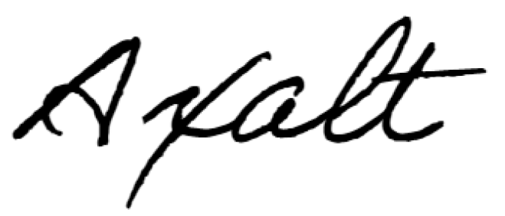
c.c. 1) Miss Vernie Wong Wan Sze (SMG 4444K)

2) ysk Auto Workshop (smg 4444k)
1 Kaki Bukit Avenue 6, Blk D,
#01-71, Autobay @ Kaki Bukit
Singapore 417883
Telephone : 9640-2541 (Danny) / Email : dannyskyeo@gmail.com

