OUR REF : ALL.Y1.2100247A-ig
YOUR REF : SJN 5522K

22 September 2021

AUTO & GENERAL INSURANCE (SINGAPORE) PTE LIMITED
Singapore Shopping Centre
190 Clemenceau Avenue #03-01
Singapore 039924

Dear Sir

1. NOTICE OF ACCIDENT TO INSURERS AND PRE-REPAIR SURVEY WITHIN 2 WORKING DAYS PURSUANT TO PARAGRAPH 2 OF THE STATE COURTS PRACTICE DIRECTIONS (AMENDMENT NO. 1 OF 2016)

2. PROPERTY DAMAGED CLAIM ARISING FROM ROAD TRAFFIC ACCIDENT ON 22/09/2021 INVOLVING VEHICLE NOS. SLU 9731L & SJN 5522K ALONG YISHUN AVENUE 9 AT ABOUT 0820 HOURS

We are instructed by MR LEE BOON YEE (owner of motor vehicle no. SLU 9731L) and/or ysk auto workshop (the motor workshop for SLU 9731L) to notify you of an accident on 22/09/2021 at about 0820 HOURS along YISHUN AVENUE 9 involving our client’s vehicle registration number [SLU 9731L] and [SJN 5522K] driven by your insured at the material time.

As a result of the accident, our client’s vehicle SLU 9731L has been damaged.

Before we proceed to repair the damaged vehicle, please let us know within 2 working days of your receipt of this notice whether you or your insurer would like to conduct a pre-repair survey of the vehicle. If we do not receive any reply from you with the stipulated timeline, we shall proceed to repair the vehicle without further reference to you.

Yours faithfully,
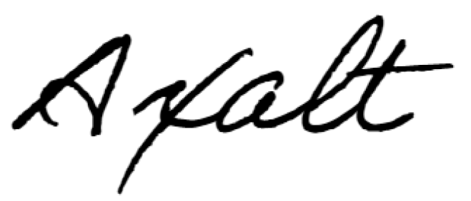
c.c. 1) Mr Lee Boon Yee (SLU 9731L)

2) ysk Auto Workshop (SLU 9731L)
1 Kaki Bukit Avenue 6, Blk D,
#01-71, Autobay @ Kaki Bukit
Singapore 417883
Telephone : 9640-2541 (Danny) / Email : dannyskyeo@gmail.com

