Your Ref: 6037949218SG005 01 October 2018
Our Ref : CI1/AIG18017633/D

Road Traffic Accident On 10 April 2015 At About 1800Hrs Along Bedok North Avenue 3 Towards Upper Changi Road, Involving Motor Cars SFW 6562M And SJD 201Y

Requested By

AIG Asia Pacific Insurance Pte Ltd

78 Shenton Way #08-16

Singapore 079120

Introduction

- I refer to your request dated 29 March 2018.

- By way of introduction, I set out below a brief description of my professional qualifications and professional work experiences.

- I am a Senior Technical Investigator and certified Accident Reconstructionist with LKK Auto Consultants Pte Ltd. I have been carrying out assessments, valuations, inspections and technical investigations of motor vehicles involved in, among other things, accident since 2007. I have also carried out accident reconstruction basing on the laws of dynamics and physics by applying mathematical equations with technique competencies aligned with international standards, ensuring proper cause analysis. Some of my clients include the Singapore Police Force, NTUC Income Insurance Co-Operative Limited, AIG Asia Pacific Insurance Pte Ltd, AXA Insurance Singapore Pte Ltd, Cycle & Carriage Industries Pte Ltd and Performance Motors Limited amongst others. I also have experience in providing analysis and commentaries on damages and faults of motor vehicles.

- I have given oral evidence as an expert witness in both the State Court and High Court, for both the prosecution and the defence for criminal proceedings and also for both the plaintiff and the defendant in civil proceedings. For instance, in MC Suit 17701/2010/Q, I acted as an expert witness in proceedings which involved among other things, a claim by an owner of a Mercedes sedan against the dealer for allegedly carrying out negligent works on the Mercedes sedan; in Suit 760/2011, I was asked by the dealer to provide my expert opinion on whether a brand new BMW sedan sold to a customer was defective. I have also been jointly appointed by both a car dealer and a car owner to provide my expert opinion as to whether the transmission of a brand-new car was defective.

- My testimony as an expert witness for accident reconstruction and speed analysis cases involving criminal proceedings for the prosecution include amongst others, MAC 2350-51/2011, an accident involving four motor cars and a motorcycle resulting in the death of the motorcyclist; DAC 039421-2011, a motor car and motorcycle accident resulting in the death of the motorcyclist; MAC 3935/12, a motor lorry and pedal bicycle accident resulting in the death of the cyclist.

- Cases where I have been engaged by an accused person include amongst others, DAC 60889-90/10, a motorcycle and motor car accident resulting in the death of the pillion rider; DAC 049130-2013 & DAC 049131-2013, self-accident involving a SMRT bus resulting in the death of one of its passengers.

- I have also carried out numerous line of sight simulation, in close replication of an accident scenario, to determine a driver’s view and sighting capability.

- I hold a certificate in Technical Accident Investigation and Reconstruction from the Society of Automotive Engineers Australasia and a National ITE Certificate (Intermediate) in Automotive Technology (Light Vehicle) from the Institute of Technical Education. I have also attended training and passed a practical examination on correct repair methods, safe and cost-effective assessment of damaged motor vehicles (Thatcham Escribe System).

- I am an affiliate member of the Society of Automotive Engineers Australasia; an affiliate member of the Institute of Automotive Engineer Assessors (UK); an associate member with the Society of Operations Engineers (UK).

Background of the Accident

- On 10 April 2015 at about 1800hrs, the motor car SJD 201Y (herein referred to as “Suzuki”) was travelling straight along Bedok North Avenue 3 in the direction of Upper Changi Road when it was involved in a collision with a motor car SFW 6562M (herein referred to as “Honda”) that was exiting out of a carpark driveway onto Bedok North Avenue 3 (herein referred to as “Accident Location”). At the time of accident, the Honda was intending to make a right turn from the carpark exit onto Bedok North Avenue 3, in a left to right direction from the perspective of the Suzuki’s travel direction.

- For this particular case I was requested to determine the approximate travelling speed of the Suzuki that was involved in the accident and; to review the Vehicle Damage Analysis / Reconstruction Report dated 04 January 2018 by M/s Koays Accident Reconstruction (herein referred to as “KAR Report”).

Documents Referred to

- I had referred to the KAR Report and the same documents that were referred to therein. As listed in paragraph 4 page 3 of the KAR Report, the documents were as follows: -

- General Insurance Association Report and Police Report of the Honda driver;

- General Insurance Association Report and Police Report of the Suzuki driver;

- Accident scene photographs;

- A visit to the Accident Location on 21 September 2018 and a review of the aforesaid documents/information were carried out in preparation of this report.

- I now set out below my analysis with respect to the approximate travelling speed of the Suzuki at the material time of accident, and my comment(s) on the KAR Report.

Speed of the Suzuki

- The speed of the Suzuki in the KAR Report was derived using statistical methodology that was referred to as Monte Carlo simulation in the KAR Report. The accuracy of results derived from using such statistical methodology is questionable, as according to the KAR Report in paragraph 45 page 10, such methodology is used when there are uncertainties in two or more variable parameters. Based on this, the reliability of the results from using the Monte Carlo simulation is clearly limited and is not an accurate or a fair assessment simply because there are variables which are unknown. With more unknown variables, the results derived would correspondingly be more inaccurate.

- Furthermore, the KAR Report had used a software program called RECTEC for or part of their computation, paragraph 40 page 10 of the KAR Report. Results derived from such software programs are dependent on the information that the user inputs into the program. As such, the outcome of the KAR Report’s calculation is dependent on the data that the user inputs. An inaccurate data inputted equals to an inaccurate result.

- In paragraph 42 page 10 of the KAR Report, the user inputs the crushed depths or intrusion sustained by the Suzuki and the Honda into RECTEC. Without the benefit of physically inspecting the Suzuki and the Honda, the measurements for the crushed depth that were inputted into RECTEC may not be a fair and accurate measurement. It is important to have an accurate crush depth measurement since RECTEC relies on this information to calculate the impact speeds.

- I note in paragraph 24 page 6 of the KAR Report that the measurements of the crushed depth were obtained by relying on photographs of the damaged Suzuki and the damaged Honda, thereafter measuring exemplar vehicles. Whilst it is recognized that the Suzuki and the Honda would no longer be in its damaged condition at the time when the KAR Report was produced, using photographs to determine the crushed depth would have its limitations. The angle of photography could mislead a person’s observations as compared to physically seeing and measuring the actual damage. A wrong observation could lead to a wrong measurement, ultimately affecting the speed analysis in the KAR Report.

- To verify the impact speed of the Suzuki that was derived by using the RECTEC software program in the KAR Report, I had used a more conventional mathematical method by inputting objective data/information as variables to obtain the approximate speed of the Suzuki at the time of its collision with the Honda. This manual calculation method applies the conservation of momentum theory where momentum pre-impact equals momentum post impact for angle collision. Calculations show that the speed of the Suzuki was approximately 44kmph at the time when it collided into the Honda (impact speed). See appendix 1 – 3 for full calculations.

- The impact speed of the Suzuki in the KAR Report, using RECTEC software program, was calculated to be 51kmph as indicated in paragraph 43 a) page 10 of the KAR Report whereas by using a more conventional manual method with objective data/information as variables, the impact speed was calculated to be 44kmph (paragraph 19 above). This represents a difference of approximately 13%, which is more than a reasonable tolerance level of between ±5% to ±10%. The difference could be attributed to the accuracy of the variables inputted by the user into the RECTEC software program, in particular the crush depth measurements of the Suzuki and the Honda.

- The 77kmph mean travelling speed of the Suzuki was derived by using the Monte Carlo simulation technique (paragraph 48 page 11 of the KAR Report). I note that the calculated speeds that were derived by using the RECTEC software program was also used as part of the information inputted for the Monte Carlo simulation technique (paragraph 46 page 11 of the KAR Report). If this was the case, then the 77kmph mean travelling speed of the Suzuki would also be inaccurate given that using RECTEC software program is not an appropriate method for this case.

- In fact, for this particular case, the travelling speed of the Suzuki could not be objectively determined due to several unknown information/data. It is because of unknown information/data that led to the use of Monte Carlo simulation technique in the KAR Report, where results derived are clearly limited, and not an accurate or a fair assessment. Applying a speed calculation method that has its limitations seems questionable, especially so when the method was used purely for the purpose of calculating the speed of the Suzuki. The objectiveness of the KAR Report would therefore seem questionable.

Cone of Vision

- The discussion on the Cone of Vision in paragraphs 58 to 64, at page 12 to 16 of the KAR Report, can be treated as theoretical at best and should not be applied to the actual sighting capability of the Suzuki driver and Honda driver for this case.

- Whilst it is fair to expect some sighting difficulty for motorists when approaching a right-angle intersection, my observations during my visit to the Accident Location did not seem to suggest that sighting difficulty had caused and/or contributed to the accident.

- During my visit to the Accident Location, I had driven along the same route and the same travelling lane that was taken by the Suzuki. It was observed that the carpark driveway was rather unnoticeable when I was approaching the T-junction, that was located before the Accident Location. The carpark driveway was not conspicuous as it appears to have blended into the surrounding landscape. The carpark driveway becomes noticeable nearer to or at the stop line of the T-junction. Based on this observation, it would be reasonable to expect that at or just before the T-junction and the roadway thereafter, the Suzuki driver was able to see the Honda as the Honda was approaching the end of the carpark driveway, coming out onto the main roadway of Bedok North Avenue 3. See photo 1 – 5 below.

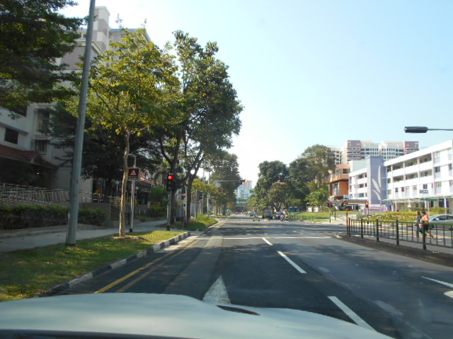
Photo 1 shows a general view of Bedok North Avenue 3 towards Upper Changi Road. This was in the same travelling direction and same travelling lane taken by the Suzuki prior to the accident. The carpark driveway where the Honda had approached was relatively unnoticeable as I was approaching the signalized T-junction located before the Accident Junction.

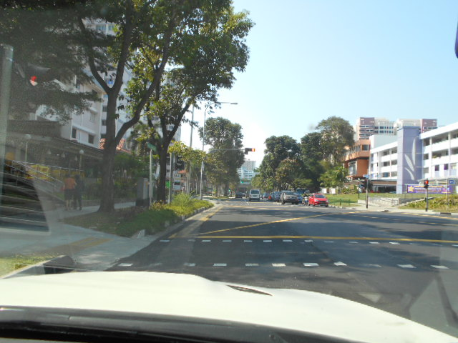
Photo 2 shows a general view of Bedok North Avenue 3 towards Upper Changi Road. This was in the same travelling direction and same travelling lane taken by the Suzuki prior to the accident. The carpark driveway where the Honda had approached becomes noticeable nearer to or at the stop line of the T-junction located before the Accident Junction.

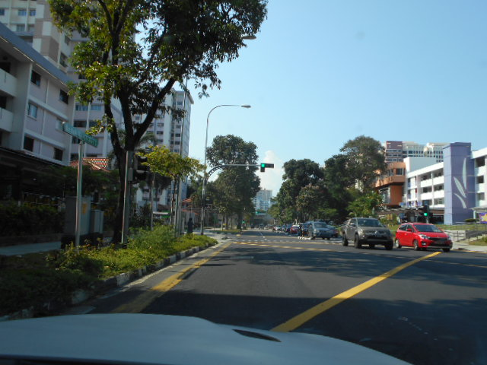
Photo 3 shows a general view of the roadway when I was entering into the signalized T-junction. The carpark driveway was clearly visible towards the front left of me. Basing on my observations, I would expect that at or just before the T-junction and the roadway thereafter, the Suzuki driver was able to see the Honda as the Honda was approaching the end of the carpark driveway, coming out onto the main roadway of Bedok North Avenue 3.

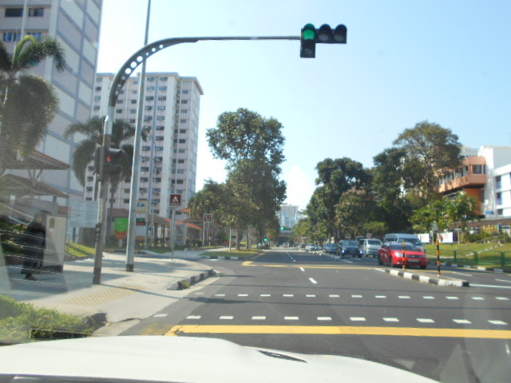
Photo 4 shows a general view of the roadway just before the Accident Location. Basing on my observations, I would expect that at or just before the T-junction and the roadway thereafter, the Suzuki driver was able to see the Honda as the Honda was approaching the end of the carpark driveway, coming out onto the main roadway of Bedok North Avenue 3.

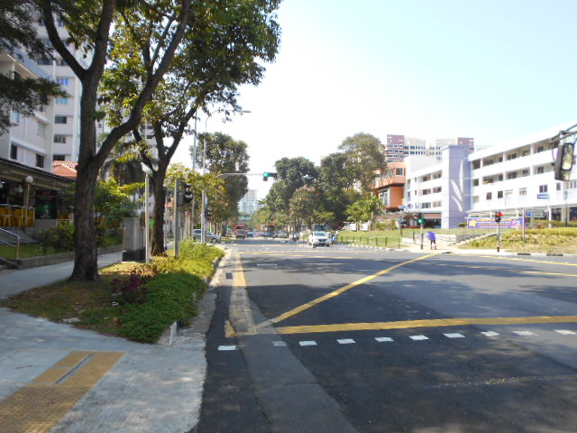
Photo 5 shows a general view of the roadway at the stop line of the T-junction before the Accident Location. A grey coloured motor car can be seen at or near the stop line of the carpark exit where the Honda had approached from. Photograph taken while standing near the road kerb.

- When driving along the carpark exit, it was observed that the roadway and vehicular traffic that was approaching from my right (Suzuki’s approach direction) was obstructed. This was about 10m before the stop line, and at this location, it would not have been possible for the driver of the Suzuki and the driver of the Honda to see each other as the obstruction was caused by a large fixed landscape.

- Nearing the stop line at the carpark driveway, I was able to see the roadway of Bedok North Avenue 3 up to the stop line at the T-junction. Vehicular traffic approaching from my right was visible at this point and onwards. From this observation, I would expect the driver of the Honda to be able to see the Suzuki approaching from the right, along the extreme left lane of Bedok North Avenue 3 when the Honda was near or at the stop line of the carpark driveway. See photo 6 - 9 below.

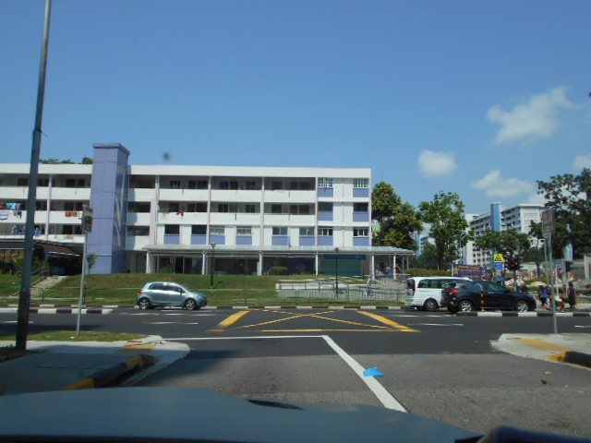
Photo 6 shows a general view of the carpark driveway which the Honda was travelling on prior to the accident. At this location, the roadway and vehicular traffic that was approaching from my right (Suzuki’s approach direction) was obstructed.

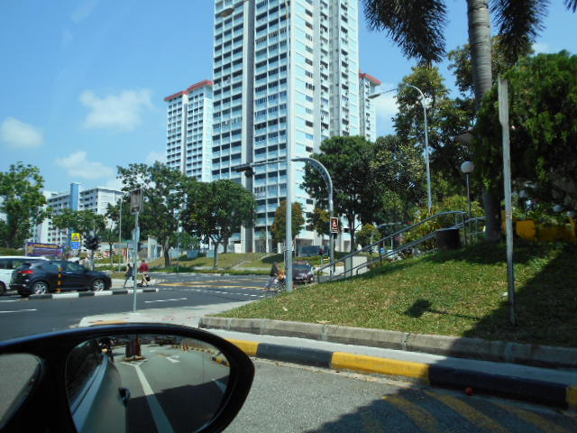
Photo 7 shows the view of the roadway and vehicular traffic that was approaching from my right (Suzuki’s approach direction). I was not able to see the roadway on the right due to obstruction caused by a large fixed landscape. This was approximately 10m before the stop line at the carpark exit. Similarly, the driver of the Suzuki would have not been able to see the Honda at this location due to the same fixed landscape.

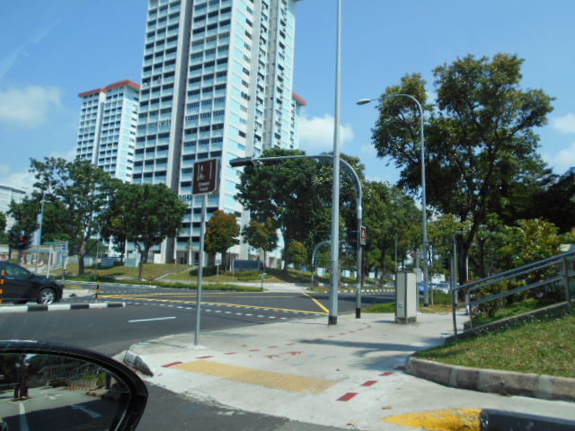
Photo 8 shows the view of the roadway and vehicular traffic that was approaching from my right (Suzuki’s approach direction) as I was near the stop line at the carpark exit. I was able to see the roadway of Bedok North Avenue 3 up to the stop line at the T-junction.

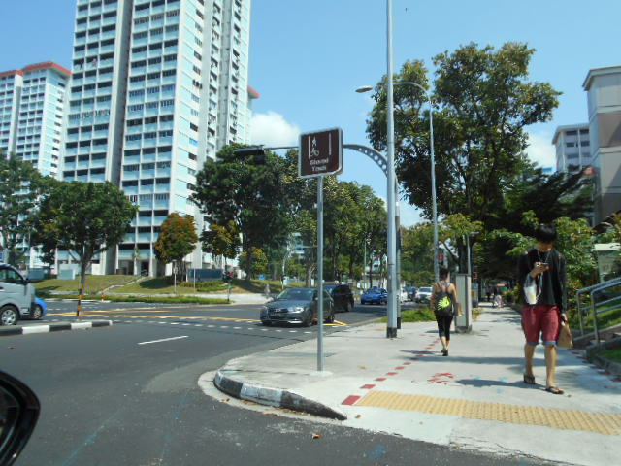
Photo 9 shows the view of the roadway and vehicular traffic that was approaching from my right (Suzuki’s approach direction) as I was at the stop line at the carpark exit. I was able to see the roadway of Bedok North Avenue 3 up to the stop line at the T-junction. From this observation, I would expect the driver of the Honda to be able to see the Suzuki approaching from the right, along the extreme left lane of Bedok North Avenue 3 when the Honda was near or at the stop line of the carpark driveway.

- Comparing my observations gathered pertaining to the sighting capability for the driver of the Suzuki and the driver of the Honda with the theoretical analysis of the same in the KAR Report, it is clear that paragraph 62 page 12 of the KAR Report is wrong. In paragraph 62 “D1 said that he checked for traffic when he was at the stop line of the Car-Park exit. At this point in time, lamppost 8 and the traffic light post could possibly have obstructed his view of V2”. From photograph 9 above, the view of the roadway along Bedok North Avenue 3 was not obstructed by any lamppost or traffic light pole. The line of sight at the stop line was up to the stop line at the signalized T-junction. Sketch plan 4 in page 15 of the KAR Report is hence an incorrect representation of the actual sighting capability of the Honda driver.

- In fact, site-survey photo 2 seen in page 47 of the KAR Report, with the captioned “D2’s point of view at the stop line”, had also showed no view obstruction for the Honda driver, contradicting the findings in the KAR Report regarding view obstruction for the Honda driver when at the stop line of the carpark driveway.

- With regard to the sighting capability for the Suzuki’s driver, paragraph 60 page 12 of the KAR Report had found that the “Point of Actual Perception” (PAP) was 44.8m away from the point of collision with the Honda. Basing on sketch plan 3 in page 14 of the KAR Report, at 44.8m away, the Suzuki would be just after the stop line, about to enter into the T-junction. From my observations, the driver of the Suzuki would have been able to see the Honda when it (Honda) was approaching the stop line at the carpark exit at the time when the Suzuki was at the stop line of the T-junction ie more than 44.8m away. Hence, the 44.8m in the theoretical analysis of the KAR Report is fair and reasonable. However, referring this 44.8m as “Point of Actual Perception” is incorrect and misleading. It should be referred to as Point of Perception instead, because at this 44.8m, the carpark driveway becomes visible to the Suzuki driver. It does not mean that the Suzuki driver had actually seen the Honda coming out of the carpark exit at this 44.8m distance away at the material time of accident.

- During my time at the Accident Location, I had observed vehicles stopped on the extreme right lane of Bedok North Avenue 3 at the T-junction, waiting to turn right onto Bedok North Street 1. The driver of the Honda had stated in his General Insurance Association Report that he saw the vehicle on his right at the traffic light junction had stopped. This was similarly written in paragraph 15 page 5 of the KAR Report.

- Although the statement was generally written without any further details of which lane was the vehicle stopped and/or colour of traffic light signal at the T-junction, it may have been possible that the “stopped vehicle” mentioned by the Honda driver was in fact a vehicle that was waiting to turn right at the T-junction and not a vehicle that had stopped due to red traffic light signal. See photo 10 below.

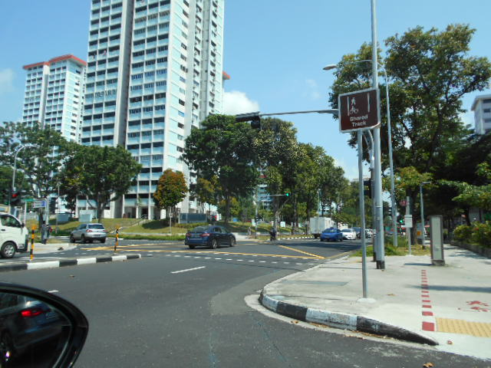
Photo 10 shows the view of the roadway and vehicular traffic from the stop line at the carpark exit. The stopped vehicle at the T-junction that was mentioned by the Honda driver could have been a vehicle that was waiting to turn right at the T-junction, similar to the arrowed vehicle in this photograph. At this point, the traffic light was showing green (circled) in both directions of Bedok North Avenue 3.

- I note that there was no clarification made with the Honda driver regarding this “stopped vehicle” in the KAR Report despite the driver’s presence during their visit to the Accident Location. Neither was there any discussion or comment in the KAR Report on whether the Suzuki had beaten the red light given the “stopped vehicle” comment by the Honda driver. Since there was no discussion regarding this aspect, it would appear to me that the colour of the traffic light signal at the T-junction was not a factor leading to the accident.

Accident Avoidance

- Paragraph 57 page 12 of the KAR Report commented that “if the Suzuki was travelling at the posted speed limit of 60kmph, the driver would have been able to completely stop the Suzuki 3m from the point of impact and there would not have been a collision”. Under the same accident avoidance aspect of this case, the accident could have also been avoided if the Honda driver had ensured that it was safe before entering Bedok North Avenue 3, regardless of the speed that the Suzuki was travelling.

- The action of not ensuring it was safe poses a risk of an accident occurring. The risk is further enhanced since it was written in paragraph 62 page 12 of the KAR Report “at the stop line of the Car-Park exit, lamppost 8 and the traffic light post could possibly have obstructed his view of V2”. Again, the objectiveness of the KAR Report seems questionable as there was no discussion and/or comment regarding the actions and/or lack of actions by the Honda driver.

- Typically, for such nature of accident where one vehicle is turning from a minor roadway (carpark exit) into a major roadway (Bedok North Avenue 3), the time when the vehicle turns into the major roadway vs the location where the other vehicle was, relative to the roadway, would have to be considered when discussing on any accident avoidance aspect. Simply put, if the Honda had exited onto Bedok North Avenue 3 when simultaneously the Suzuki was at the end of the T-junction (approximately 17.48m from the point of impact), the accident would have still occurred even if the Suzuki was travelling at the posted speed limit of 60kmph.

- The comment in paragraph 57 page 12 of the KAR Report “if D2(V2) had travelled at the speed limit of 60kmph at the material time, he could have completely stopped his vehicle (3m) before the POI; and there would not have been a collision”, and similarly found in the conclusions at paragraph 65 d) page 17 of the KAR Report, is therefore not a fair assessment of the case.

Conclusion

- Having reviewed the documents/information for this particular case, I am of the view that the conclusions contained in paragraph 65 a) to d) page 17 of the KAR Report, cannot be considered to be reasonably objective. This include the 77kmph travelling speed of the Suzuki.

- Because of the use of variables that are unknown, the 77kmph travelling speed of the Suzuki, determined by means of a statistical methodology that was referred to as Monte Carlo simulation technique in the KAR Report, is not a fair and accurate assessment. For this particular case, the travelling speed of the Suzuki cannot be objectively determined due to the lack of data/information required for speed analysis, for example the actual distance when the Suzuki driver had seen the Honda entering into Bedok North Avenue 3 etc.

- Furthermore, the initial 51kmph impact speed assessment of the Suzuki, used as part of the information inputted for the Monte Carlo simulation, was by itself questionable given the accuracy of the data inputted into the software program (RECTEC) to obtain this impact speed. My application of a more conventional method using objective data/information as variables, produced an impact speed of 44kmph to the Suzuki.

- The discussion on the line of sight in the KAR Report, in particular for the Honda driver, contradicts the actual line of sight available to the Honda driver, especially when site-survey photo 2 shown in page 47 of the KAR Report had showed no view obstruction at the stop line of the carpark driveway. My observations during my visit to the Accident Location also did not suggest that the Honda driver would have difficulty seeing the Suzuki approaching from his right when the Honda was near or at the stop line of the carpark driveway. Refer to photographs 8 and 9 above.

- The KAR Report seem to have only took into account accident avoidance aspect from the perspective of the Suzuki driver. Factors attributing to the accident from the perspective of the Honda driver were not discussed or commented upon in the KAR Report.

- The accident had occurred when the Suzuki was travelling along the main roadway of Bedok North Avenue 3. The driver of the Honda, exiting out of a carpark driveway, could and should have seen the Suzuki approaching from his right when the Honda was near or at the stop line of the carpark driveway. The accident would not have occurred If the driver of the Honda had ensured that it was safe before entering Bedok North Avenue 3, regardless of the speed that the Suzuki was travelling.

Ang Bryan Tani
Senior Technical Investigator
Technical Investigation & Reconstructionist (SAE-A)
DISCLAIMER OF LIABILITY TO THIRD PARTIES:- This Report is made solely for the use and benefit of the Client named on the front page of this Report. No liability or responsibility whatsoever, in contract or tort, is accepted to any third party who may rely on the Report wholly or in part. Any third party acting or relying on this Report, in whole or in part, does so at his or her own risk.

