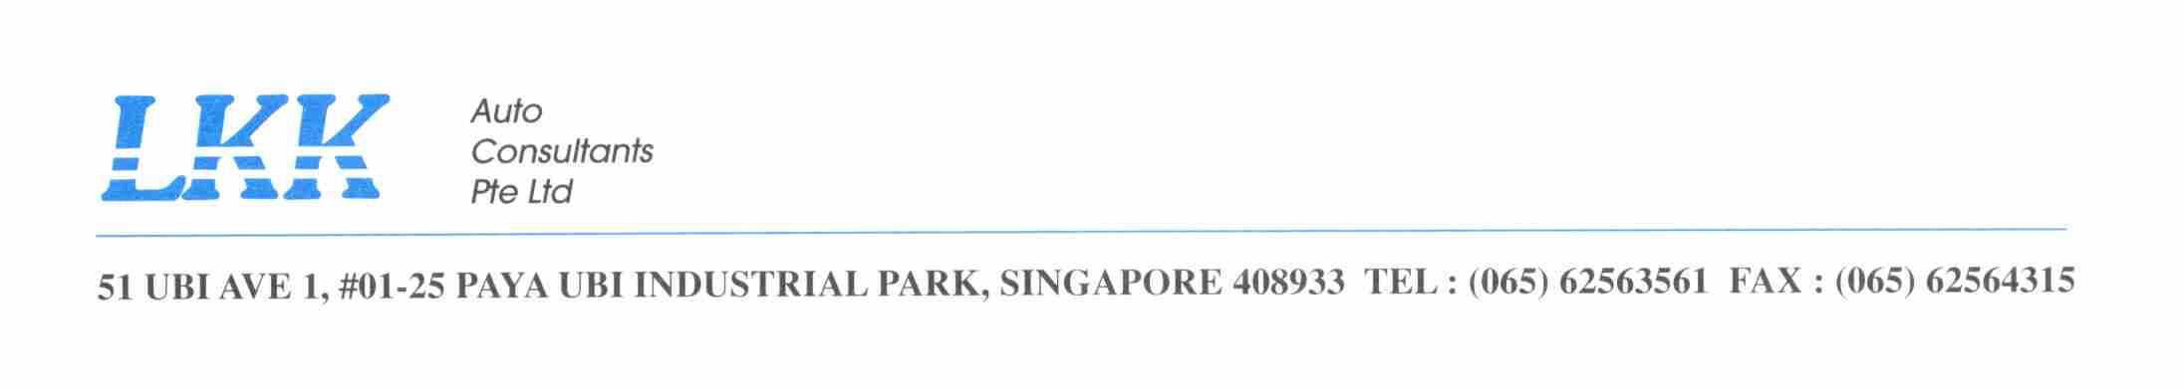To : MINDEF – ARMY
Attention : 1WO RAVEEN / PTE JOE
Fax no : 6307 4520
Your ref : FY18/19/0020
Our ref : CC2/MIDA18014273/j
Date : 21 JANUARY 2019

ACCIDENT INVOLVING MID 34543 & GBG 4735B ON 28 JULY 2018

MID vehicle changed lane.
Our draft to offer to Third-Party claim below. For your approval.

On without prejudice basis and without admission of liability, our principal MINDEF is prepared to settle your client’s claim as follows:

1. Cost of Repairs | $ 620.60 (GST included)
2. Loss of Rental (2 days x $130.01) | $ 260.00 (GST included)
Total | $ 880.60

For your acceptance.

Yours faithfully

Joy Irene Bascao
Claims Section
joyirene@lkkauto.com
Tel : 6841 2409
Fax: 6741 4108

