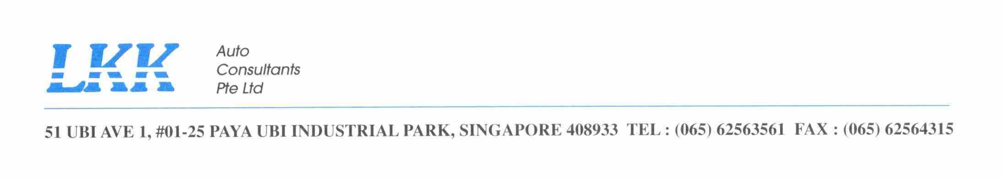

FACSIMILE

To : MINDEF – Army
Attention : 1WO SIVAJI RAJAH
Fax no : 6307 4520
Your ref : FY18/19/0003
Our ref : CC2/MIDA18007672/j
Date : 12 APRIL 2018

ACCIDENT INVOLVING MID 20563 & SJW 4355K ON 07 APRIL 2018

We refer to the above matter and your faxed dated 09 April 2018.

Please forward the following as indicated below:

- SAF 1201/1202
- Police Report
- Final Bill
- Original photographs (SAF vehicle)

Please contact the undersigned should you require any clarification with the matter.

Yours faithfully

Joy Irene Bascao
Claims Section
joyirene@lkkauto.com
Tel : 6841 2409
Fax: 6741 4108

