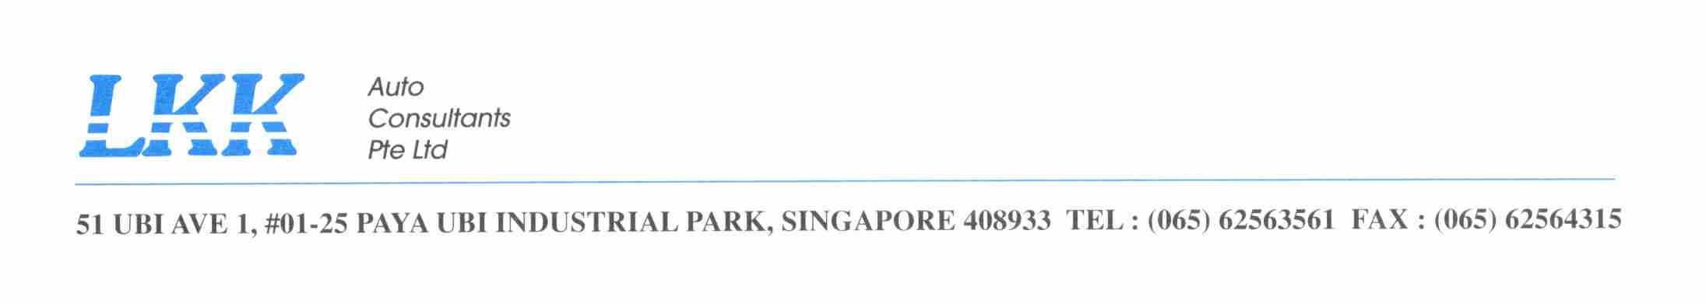To : MINDEF – ARMY
Attention : 1WO RAVEEN / PTE JOE
Fax no : 6307 4520
Your ref : FY16/17/0042
Our ref : CC2/MIDA16016894/j
Date : 21 JANUARY 2019

ACCIDENT INVOLVING MID 23151 & SKW 1277K ON 21 AUG 2016

MID vehicle and Civilian vehicle has given conflicting versions. Liability 50%.
Our draft to offer to AIG Insurance below. For your approval.

Please be informed that the Treasury Collision Agreement is applicable and the computation will be as follows:

- Cost of Repair to your client vehicle (SKW 1277K) | : $ 5,420.70
- Cost of Repair to our vehicle (MID 9780) | : NIL
TCA reimbursement to MINDEF by AIG @ 50% | : $ 2,710.35  : $ 210.00 (SURVEY FEE)  : $ 2,920.35

Yours faithfully

Joy Irene Bascao
Claims Section
joyirene@lkkauto.com
Tel : 6841 2409
Fax: 6741 4108

