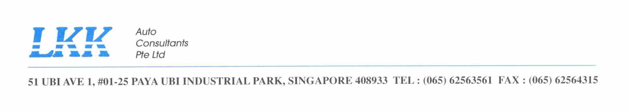

Your Ref: FY 15/16/0031
Our Ref: CC2/MIDA15013377/j

28 May 2018

HQ-TRANSPORT COMMAND
Kranji Camp III
151 Chua Chu Kang Way
Singapore 688248

ATTENTION : 1WO RAVEEN

Dear Sir,

ACCIDENT INVOLVING MID 21253 & SGY 7036L ON 04 AUGUST 2015

We refer to the above matter.

We have concluded settlement with M/s FASTECH AUTO PTE LTD acting for third party (DV enclosed).

We are processing TCA recovery from TP insurer M/s NTUC Income Insurance Co-operative Ltd and will close our file upon completion of the recovery/settlement.

Our note of charges enclosed for your necessary action.

Summary: -
 | Date of submission: | Remarks:
Professional Service Fee |  | Pending TCA completion
Disbursement Fee |  | DV from civilian enclosed
TCA |  | Processing

Yours faithfully

Joy Irene Bascao
Claims Section
DID: 6841 2409
Fax: 6741 4108
E-mail: joyirene@lkkauto.com

