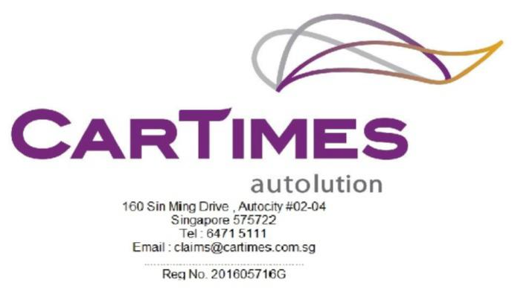

_____________________________________________________________________________________
Our Ref: SNM 3516 A

Your Ref: SHC 4806 E

10 June 2024

MS First Capital Insurance Ltd BY EMAIL ONLY
36 Robinson Road (Motor_Claims@msfirstcapital.com.sg)
#16-01
City House
Singapore 068877
Dear Sir,
RE: PROPERTY DAMAGE CLAIM
CLAIMANT: KOH CHIN YONG
ACCIDENT INVOLVING SNM 3516 A & SHC 4806 E ALONG MARINA BOULEVARD ON 08/06/2024.

- We act for KOH CHIN YONG, the owner of motor vehicle no. SNM 3516 A, which was involved in the aforesaid accident.

- We hereby give you NOTICE that we are claiming against your insured motor vehicle no. SHC 4806 E for damages, costs and disbursements as a result of your insured driver’s negligence.

- Kindly let us know if you wish to conduct a pre-repair inspection on our client’s motor vehicle at M/s Cartimes Autolution at 160 Sin Ming Drive #02-04 Autocity Singapore 575722 and kindly arrange with Ms Summer at 6471 5111.

- If we do not here from you within the next two (2) working days , we shall advice our client to proceed with their own inspection and repairs.
Yours Sincerely
Ms Summer

