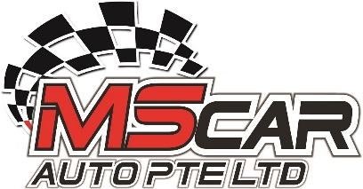

Date : 12th November 2024

To Whom It may concern

Re: Letter of Authorisation

Dear Sir,

This is to authorise Mr Ng Soon Huat of Nric : S 6934991I to make an accident report on behalf of the company for vehicle SND 53K that involved in an accident on 9th November 2024

Thank You
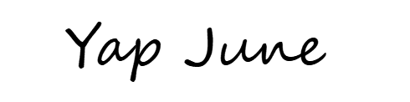

--------------
Signature

